Part A — Project Setup
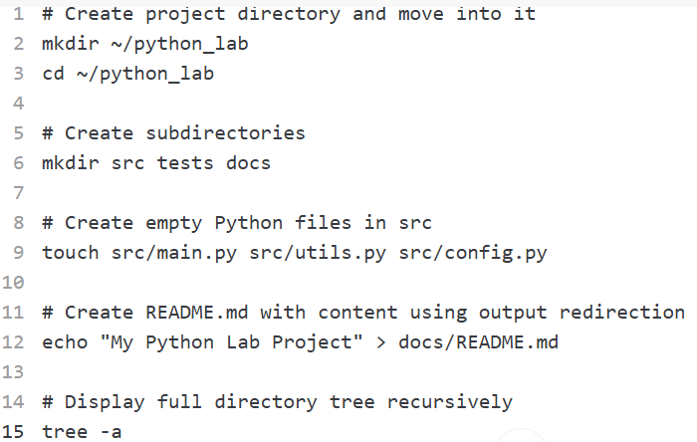

Worksheet paragraph 1 (what each command does): mkdir creates a directory; chaining && cd moves into it immediately. The second mkdir src tests docs creates three subfolders in one call. touch creates empty files without opening an editor. echo "text" > file redirects the string into a new file (overwriting it if it exists) instead of using an interactive editor. find. | sort walks the directory tree and prints every path, sorted alphabetically, so the whole structure is visible at once.
Worksheet paragraph 2 (why separate src/tests/docs): Even in a small project, separating source code, tests, and documentation keeps each concern isolated so tools (test runners, packaging, doc generators) can target the right folder without extra config, and it prevents clutter as the project grows. It also mirrors the structure of real-world professional projects, so the habits (and any build/CI tooling you later add) scale without a painful reorganization later.
Part B — Git Init and First Commit
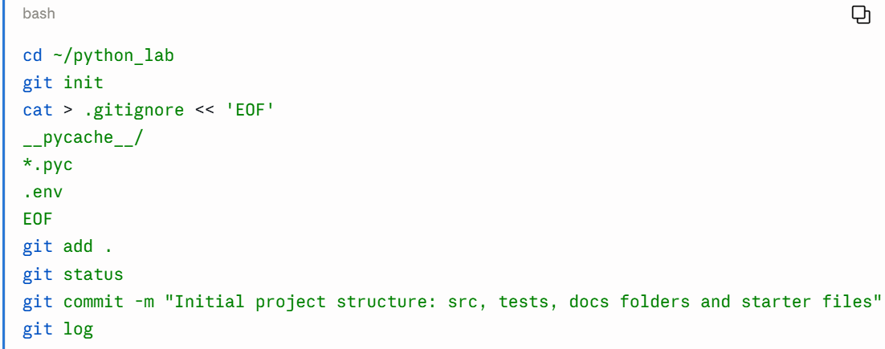
Worksheet — .gitignore explanation: .gitignore tells Git which files/patterns to never track or stage, even with git add .. __pycache__/ ignores Python's compiled bytecode cache folders, and *.pyc ignores individual compiled bytecode files — both are auto-generated on every run and would create noisy, meaningless diffs if committed. .env is ignored because it typically holds secrets (API keys, credentials) that should never be pushed to a shared or public repo. Commit history: git log shows a chronological record of every commit — author, date, and message — which reveals how the project evolved, who changed what and when, and gives you the ability to trace bugs back to the change that introduced them or revert to any earlier working state.

Part C - Writing and Committing Python Code
utils.py (create in src/utils.py)
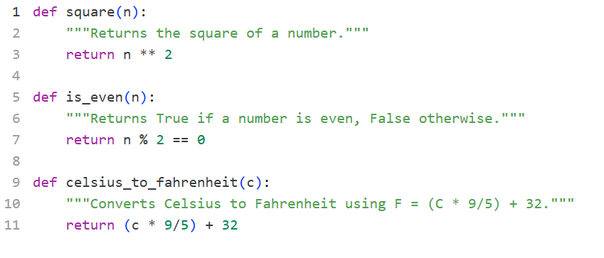
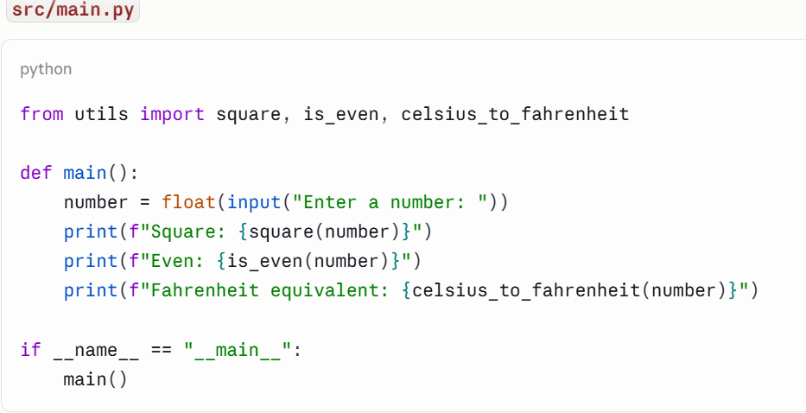

Run and test it
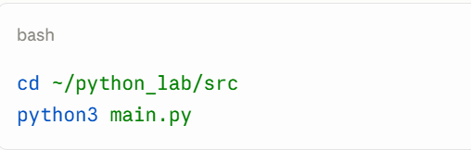
Run it three separate times with different inputs and capture the output. I verified this exact code with inputs 7, -10, and 15:
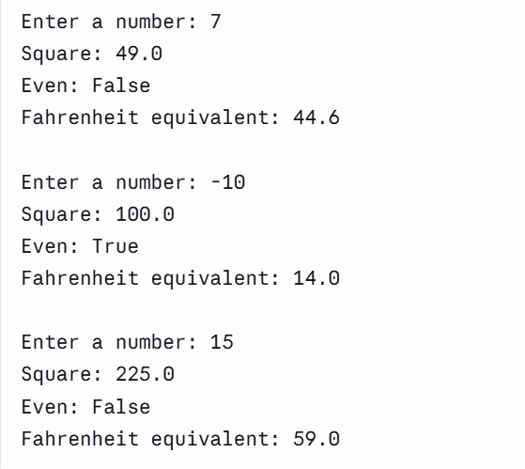
Then commit:
cd ~/python_lab
git add .
git commit -m "Add utils functions and main program for square, even/odd, and C-to-F conversion"

Worksheet — how imports connect the files: from utils import square, is_even, celsius_to_fahrenheit tells Python to load the utils module (i.e., utils.py, found because it's in the same directory as main.py) and bind those three specific function names into main.py's namespace. Python locates the module via its module search path (sys.path), which includes the script's own directory by default — that's why utils.py doesn't need to be installed as a package to be imported this way.

Part D — Publishing to GitHub and Branch Workflow

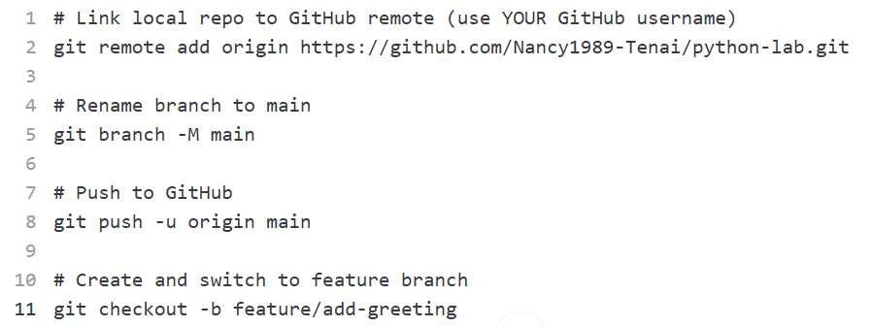

Update utils.py:
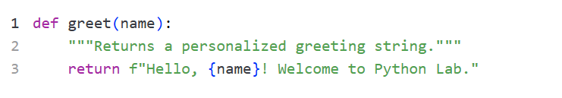
Update main.py
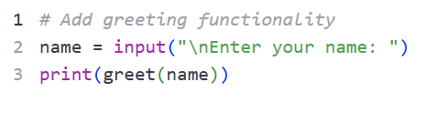
update the import in main.py:
Commands to commit and push feature branch:
